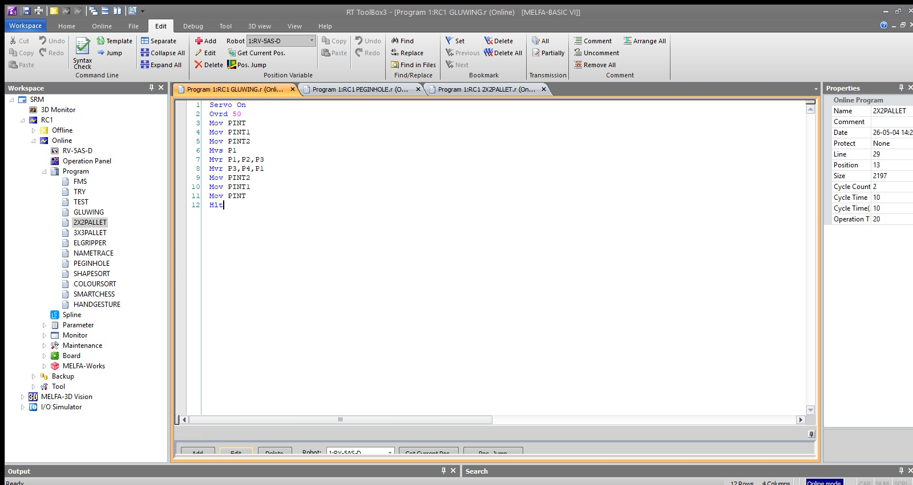
Figure 1: RT ToolBox3 editor showing MELFA-BASIC VI code with 3D circular interpolation (Mvr) for continuous dispensing.
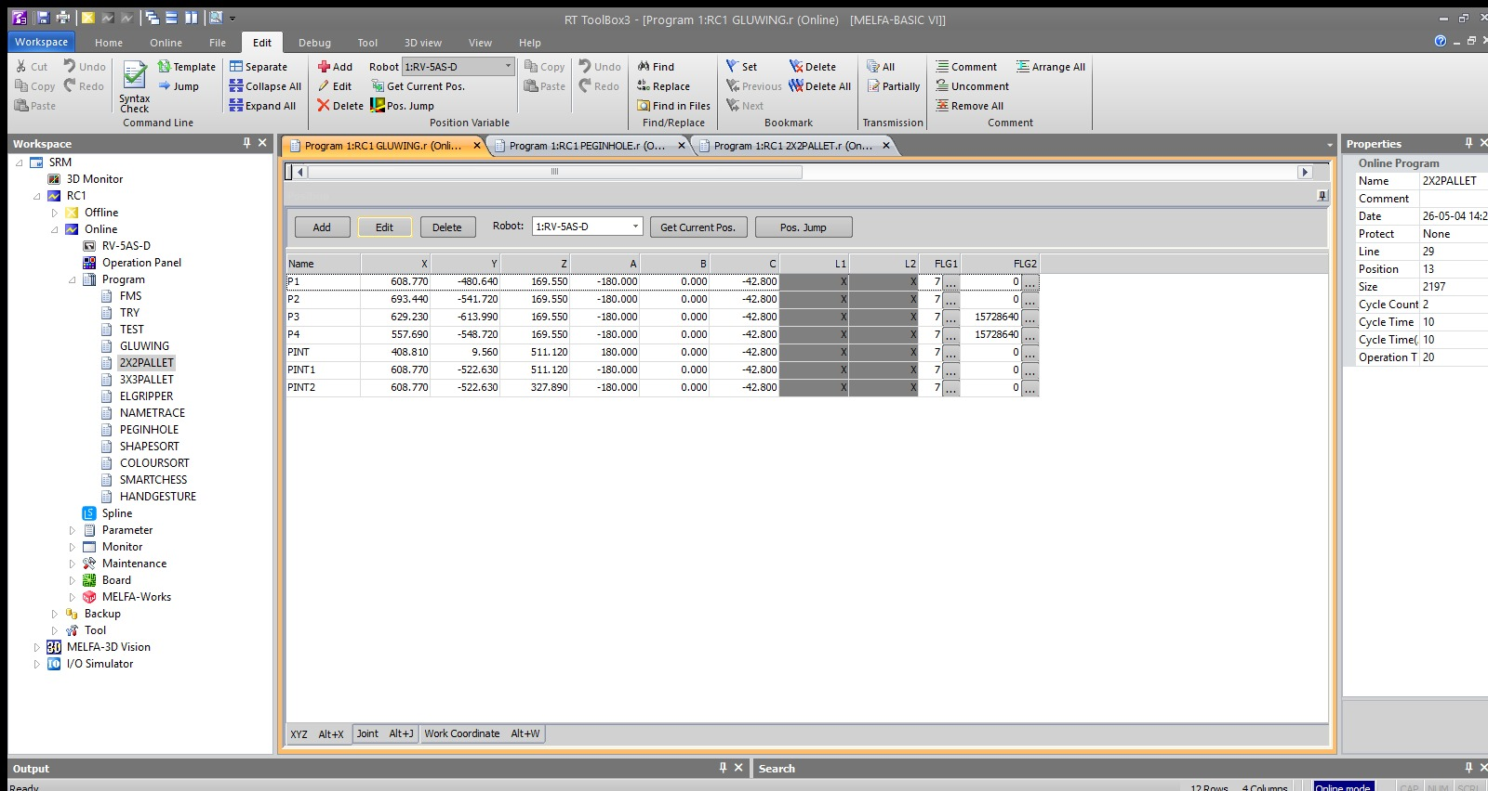
Figure 2: Position variable table with coordinates for the circular rim (P1–P4) and intermediate safety nodes (PINT series).
Expt No:  03 | DYNAMIC PATH SYNTHESIS AND CONSTANT VELOCITY CONTROL
Date:
18 / 02 /2026

- AIM:
To construct continuous, non-linear trajectories for industrial dispensing (glueing) applications and analyze the impact of constant velocity control and path blending on trajectory fidelity using a 6-axis industrial manipulator.

- APPARATUS REQUIRED:
  - Manipulator System: Mitsubishi RV-8CRL-D 6-axis industrial robot.
  - Control Hardware: CR800-D series dedicated robot controller.
  - Software Suite: RT ToolBox3 integrated engineering environment with Oscillograph tool enabled.
  - End-of-Arm Tooling : Simulated dispensing nozzle or glue gun configured within the tool coordinate system
  - Infrastructure: Practical board for glueing paths and standard communication interface.

- THEORY:
Industrial applications such as glueing, sealing, and coating require a constant velocity at the Tool Center Point (TCP) to ensure uniform material thickness. Any variation in speed at trajectory nodes results in non-uniform material accumulation.
- Core Principle:
Dynamic path synthesis involves blending individual motion vectors into a continuous stream, ensuring the robot does not decelerate to a complete stop at intermediate waypoints.
- Working Mechanism:
  - Arc Interpolation (Mvr): Unlike standard circular commands, Mvr generates smooth paths through three designated points (Start, Passed, and End), allowing for the construction of complex non-linear dispensing contours.
  - Continuous Path Control (Cnt): By invoking the Cnt 1 command, the controller’s algorithm blends the acceleration and deceleration phases of sequential commands. This ensures fluid motion transitions across via-points, preserving geometric integrity and maintaining constant feed rates.

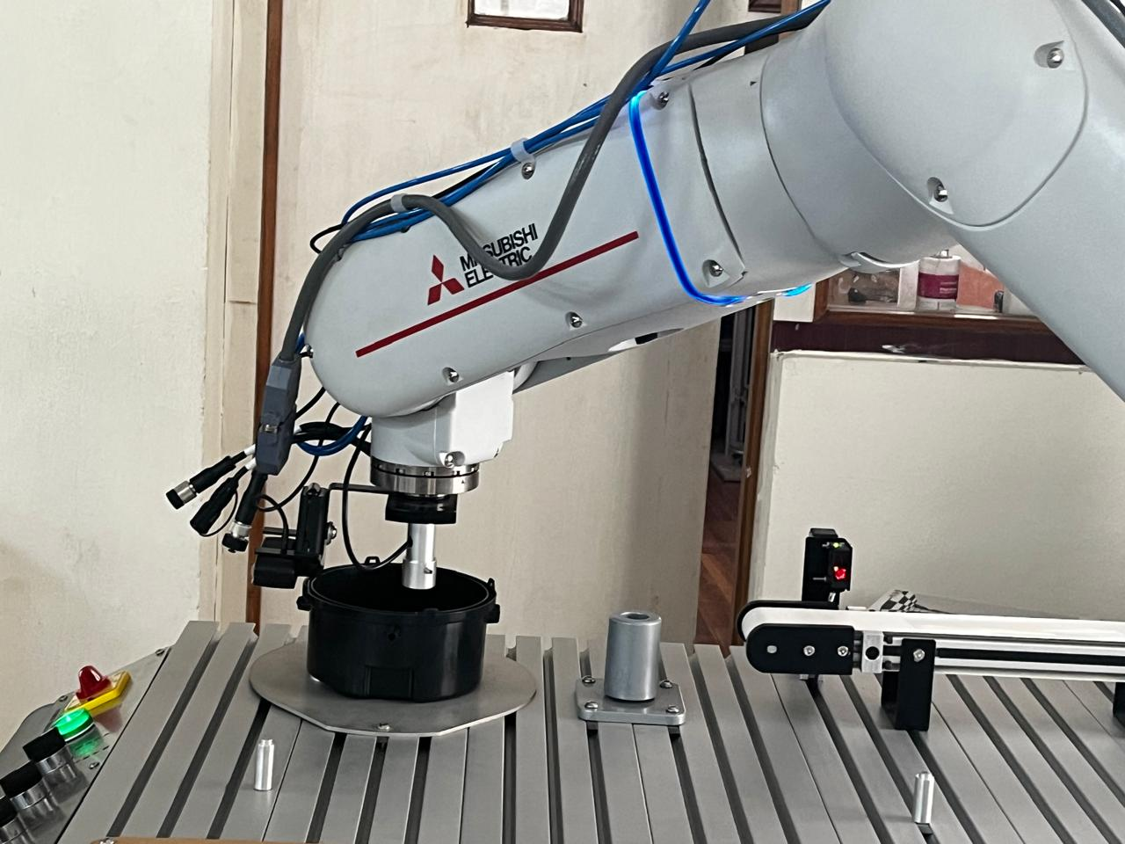
Figure 3: Workspace setup with Mitsubishi RV-5AS-D robot aligned over the circular fixture before dispensing.

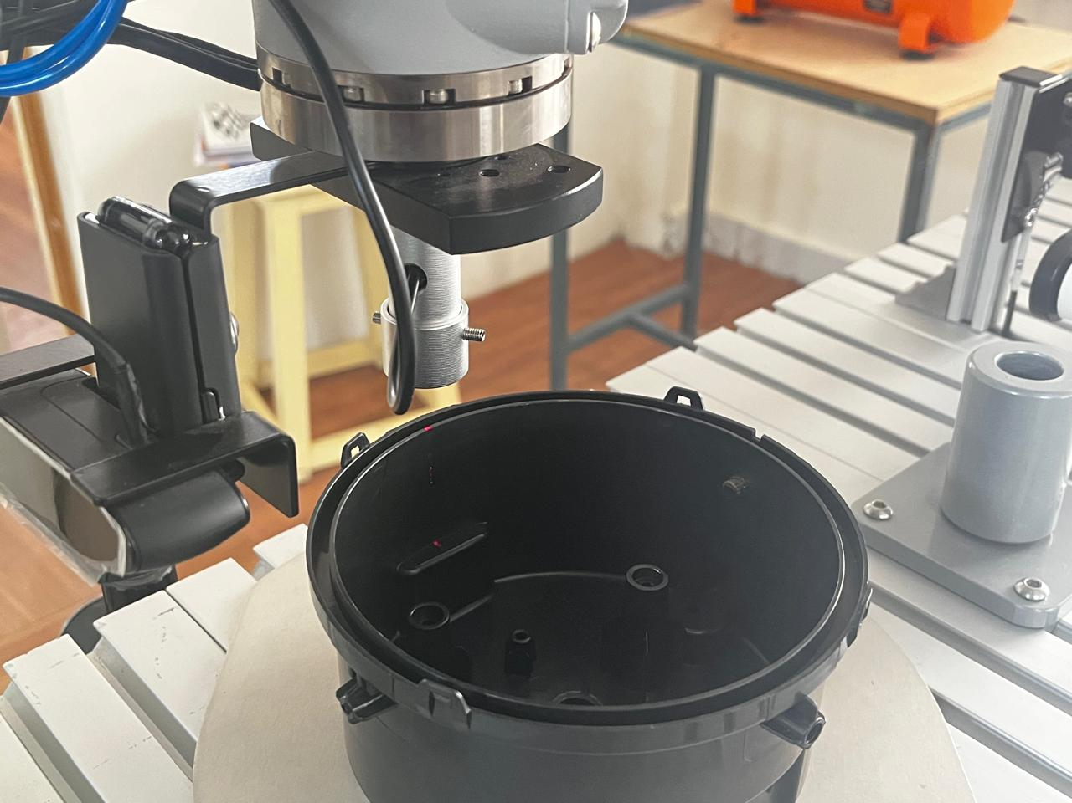
Figure 3: End-effector performing linear approach to contact point (P1) before the 360° trajectory.
- PROCEDURE:
- Setup & Connections:
Establish communication between the workstation and the CR800-D controller. Interface the simulated dispenser trigger with the controller's digital output (e.g., Output 10). Define the absolute coordinates for the path entrance (p1), curve passing point (pPassed), and exit point (pEnd).
- Algorithm & Logic:
  - Enable system servos and set the operational speed override (Ovrd) to a constant value suitable for dispensing.
  - Enable continuous path blending using the Cnt 1 instruction.
  - Navigate to a stabilized approach height above the start coordinate.
  - Trigger the dispenser activation signal (M_Out).
  - Execute the combined linear (Mvs) and arc (Mvr) segments to synthesize the contour.
  - Deactivate the dispenser signal at the terminal node and depart vertically to a safe origin.
- Execution Steps:
  - Load the logic into RT ToolBox3 and perform a Step Run in manual mode to verify the approach/escape heights.
  - Transition to Automatic mode and execute the full kinematic sequence.
  - Open the Oscillograph tool and configure it to monitor Tool point speed (FB).
- Observation Instructions:
Analyze the Oscillograph data to confirm that the feed rate remained stable during the transition from Mvs to Mvr. Observe the physical path for any mechanical vibration or "blobbing" at the intersection points.

- RESULT AND OBSERVATION:
The robotic system successfully synthesized a continuous, high-fidelity dispensing trajectory. The implementation of Cnt 1 logic, combined with constant velocity override, ensured a stable feed rate across the arc segments without deceleration at intermediate nodes, as verified by Oscillograph feedback and visual inspection.

